AFH Chapter 6 – Takeoffs and Departure Climbs (Draft A v1)
EAA Power-loss on Takeoff Working Group Edits, February 2026
Edits in BOLD red font

Introduction
About twenty percent of all yearly general aviation (GA) accidents occur during takeoff and departure climbs, and more than half of those accidents are the result of some sort of failure of the pilot. A significant number of takeoff accidents are the result of loss of control of the airplane. When compared to the entire profile of a normal flight, this phase of a flight is relatively short, but the pilot workload is intense. Because of the low altitude, high power setting, and rapidly changing flight conditions, there is little time available for analysis or correction once the airplane becomes airborne.
This chapter discusses takeoffs and departure climbs in airplanes under normal conditions and under conditions that require maximum performance. Though it may seem relatively simple, the takeoff often presents the most hazards of any part of a flight. The importance of thorough knowledge of procedures and techniques coupled with proficiency in performance cannot be overemphasized. Effective risk management during takeoff begins before brake release and includes consideration of available options should an abnormal condition or loss of power occur during the initial climb.
The discussion in this chapter is centered on airplanes with tricycle landing gear (nose-wheel). Procedures for conventional gear airplanes (tail-wheel) are discussed in Chapter 14: Transition to Tailwheel Airplanes. The manufacturer’s recommended procedures pertaining to airplane configuration, airspeeds, and other information relevant to takeoffs and departure climbs in a specific make and model airplane are contained in the Federal Aviation Administration (FAA)-approved Airplane Flight Manual and/or Pilot’s Operating Handbook (AFM/POH) for that airplane. If any of the information in this chapter differs from the airplane manufacturer’s recommendations as contained in the AFM/POH, the airplane manufacturer’s recommendations take precedence.

Terms and Definitions (Draft A v1)
Although the takeoff and climb is one continuous maneuver, it will be divided into three separate steps for purposes of explanation: 1.) takeoff roll; 2.) lift-off; and 3.) initial climb after becoming airborne. Refer to Figure 6-1 and the detail below. These phases are described separately because aircraft performance, pilot workload, and available options change rapidly as altitude and airspeed increase.
• Takeoff roll (ground roll) is the portion of the takeoff procedure during which the airplane is accelerated from a standstill to an airspeed that provides sufficient lift for it to become airborne.
• Lift-off is when the wings are lifting the weight of the airplane off the surface. In most airplanes, this is the result of the pilot rotating the nose up to increase the angle of attack (AOA).
• The initial climb begins when the airplane leaves the surface and a climb pitch attitude has been established. Normally, it is considered complete when the airplane has reached a safe maneuvering altitude or an en route climb has been established. During the initial climb, limited altitude and high workload may constrain the pilot’s ability to analyze and respond to abnormal conditions.

Prior to Takeoff
Before going to the airplane, the pilot should check the POH/AFM performance charts to determine the predicted performance and decide if the airplane is capable of a safe takeoff and climb for the conditions and location. [Figure 6-2] High density altitudes reduce engine and propeller performance, increase takeoff rolls, and decrease climb performance. A more detailed discussion of density altitude and how it affects airplane performance can be found in the Pilot’s Handbook of Aeronautical Knowledge (FAA-H-8083-25, as revised). Performance planning should account not only for normal operations, but also for the reduced margins available during the initial climb following liftoff.
All run-up and pre-takeoff checklist items should be completed before taxiing onto the runway or takeoff area. As a minimum before every takeoff, all engine instruments should be checked for proper and usual indications, and all controls should be checked for full, free, and correct movement. The pilot should also consider available options if an engine failure occurs after takeoff. These options include the preferred direction for any emergency turns to landing sites based on the departure path, altitude, wind conditions, and terrain. This consideration should be completed prior to brake release, as limited time and altitude may preclude meaningful analysis once airborne.
In addition, the pilot should make certain that the approach and takeoff paths are clear of other aircraft. At nontowered airports, pilots should announce their intentions on the common traffic advisory frequency (CTAF) assigned to that airport. When operating from a towered airport, pilots need to contact the tower operator and receive a takeoff clearance before taxiing onto the active runway.
Taking off immediately behind another aircraft, particularly a large and heavy transport airplane, creates the risk of a wake turbulence encounter, and a possible loss of control. However, if an immediate takeoff behind a large heavy aircraft is necessary, the pilot should plan to minimize the chances of flying through an aircraft’s wake turbulence by avoiding the other aircraft’s flightpath or rotating prior to the point at which the preceding aircraft rotated. While taxiing onto the runway, the pilot should select ground reference points that are aligned with the runway direction to aid in maintaining directional control and alignment with the runway center line during the climb out. These may be runway centerline markings, runway lighting, distant trees, towers, buildings, or mountain peaks.
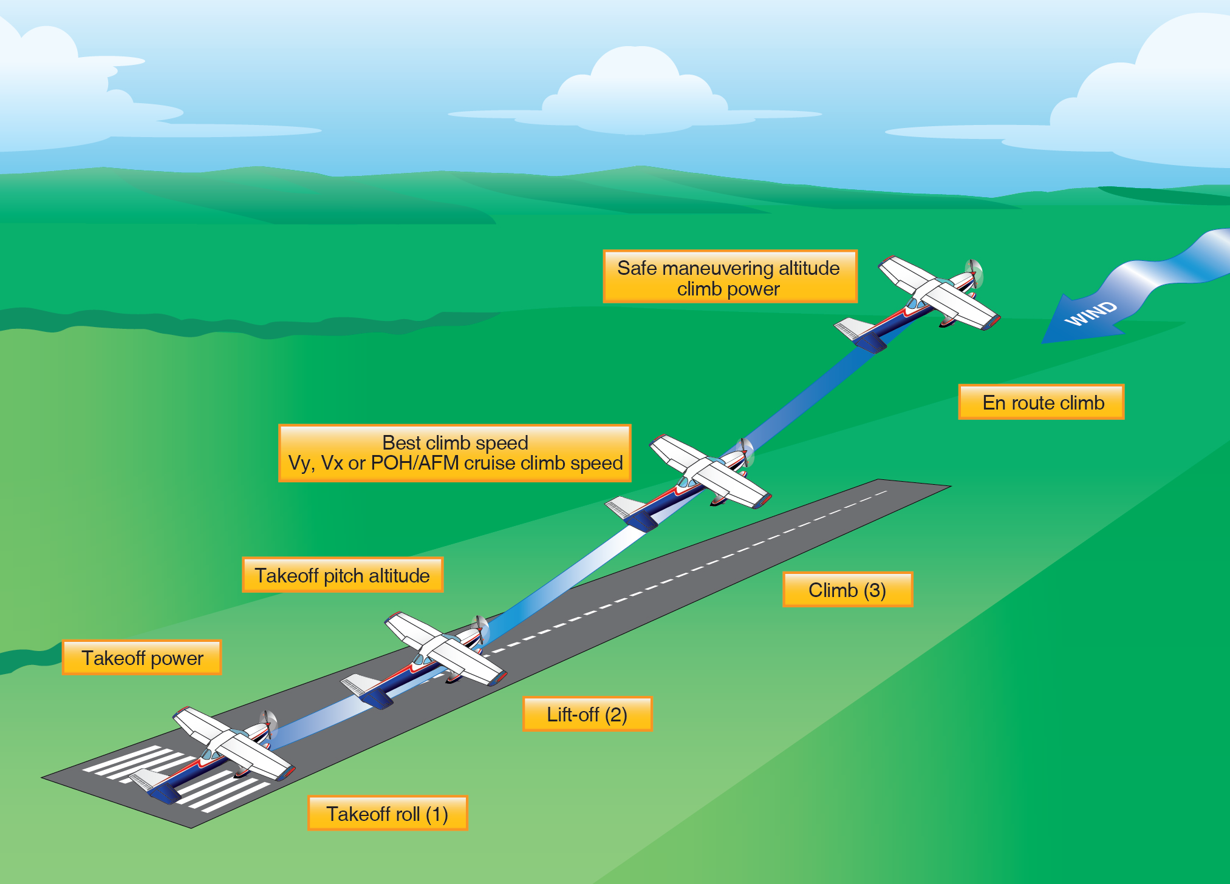
Enroute Climb Power and airspeed
Rotation/Liftoff Attitude
Safe maneuvering altitude (aircraft and condition dependent)
Initial Target Climb Speed
(Vx, Vy, POH/AFM)
Figure 6-1. Takeoff and climb
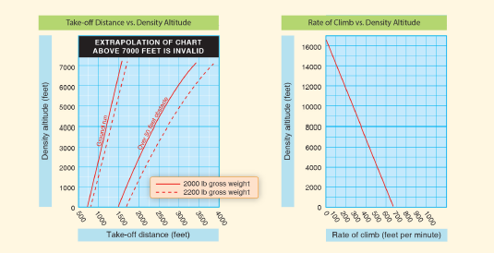
Figure 6-2. Performance chart examples
Normal Takeoff
A normal takeoff is one in which the airplane is headed into the wind; there are times that a takeoff with a tail wind is necessary. However, the pilot should consult the POH/AFM to ensure the aircraft is approved for a takeoff with a tail wind and that there is sufficient performance and runway length for the takeoff. The pilot should also ensure that the takeoff surfaces are firm and of sufficient length to permit the airplane to gradually accelerate to normal lift-off and climb-out speed, and there are no obstructions along the takeoff path.
There are two reasons for making a takeoff as nearly into the wind as possible. First, since the airplane depends on airspeed, a headwind provides some of that airspeed even before the airplane begins to accelerate into the wind. Second, a headwind decreases the ground speed necessary to achieve flying speed. Slower ground speeds yield shorter ground roll distances and allow use of shorter runways while reducing wear and stress on the landing gear.
Takeoff Roll
For takeoff, the pilot uses the rudder pedals in most general aviation airplanes to steer the airplane’s nose-wheel onto the runway centerline to align the airplane and nose-wheel with the runway. After releasing the brakes, the pilot should advance the throttle smoothly and continuously to takeoff power. An abrupt application of power may cause the airplane to yaw sharply to the left because of the torque effects of the engine and propeller. This is most apparent in high horsepower engines. As the airplane starts to roll forward, assure both feet are on the rudder pedals so that the toes or balls of the feet are on the rudder portions, not on the brake. Check the engine instruments for indications of a malfunction during the takeoff roll.
In nose-wheel type airplanes, pressures on the elevator control are not necessary beyond those needed to steady it. Applying unnecessary pressure only aggravates the takeoff and prevents the pilot from recognizing when elevator control pressure is actually needed to establish the takeoff attitude.
As the airplane gains speed, the elevator control tends to assume a neutral position if the airplane is correctly trimmed. At the same time, the rudder pedals are used to keep the nose of the airplane pointed down the runway and parallel to the centerline. The effects of engine torque and P-factor at the initial speeds tend to pull the nose to the left. The pilot should use whatever rudder pressure is needed to correct for these effects or winds. The pilot should use aileron controls into any crosswind to keep the airplane centered on the runway centerline. The pilot should avoid using the brakes for steering purposes as this will slow acceleration, lengthen the takeoff distance, and possibly result in severe swerving.
As the speed of the takeoff roll increases, more and more pressure will be felt on the flight controls, particularly the elevators and rudder. If the tail surfaces are affected by the propeller slipstream, they become effective first. As the speed continues to increase, all of the flight controls will gradually become effective enough to maneuver the airplane about its three axes. At this point, the airplane is being flown more than it is being taxied. As this occurs, progressively smaller rudder deflections are needed to maintain direction.
The feel of resistance to the movement of the controls and the airplane’s reaction to such movements are the only real indicators of the degree of control attained. This feel of resistance is not a measure of the airplane’s speed, but rather of its controllability. To determine the degree of controllability, the pilot should be conscious of the reaction of the airplane to the control pressures and immediately adjust the pressures as needed to control the airplane. The pilot should wait for the reaction of the airplane to the applied control pressures and attempt to sense the control resistance to pressure rather than attempt to control the airplane by movement of the controls.
A student pilot does not normally have a full appreciation of the variations of control pressures with the speed of the airplane. The student may tend to move the controls through wide ranges seeking the pressures that are familiar and expected and, as a consequence, over-control the airplane.
The situation may be aggravated by the sluggish reaction of the airplane to these movements. The flight instructor should help the student learn proper response to control actions and airplane reactions. The instructor should always stress using the proper outside reference to judge airplane motion. For takeoff, the student should always be looking far down the runway at two points aligned with the runway. The flight instructor should have the student pilot follow through lightly on the controls, feel for resistance, and point out the outside references that provide the clues for how much control movement is needed and how the pressure and response changes as airspeed increases. With practice, the student pilot should become familiar with the airplane’s response to acceleration up to lift-off speed, corrective control movements needed, and the outside references necessary to accomplish the takeoff maneuver.
Lift-Off
Since a good takeoff depends on the proper takeoff attitude, it is important to know how this attitude appears and how it is attained. The ideal takeoff attitude requires only minimum pitch adjustments shortly after the airplane lifts off to attain the speed for the best rate of climb (VY). [Figure 6-3] The pitch attitude necessary for the airplane to accelerate to VY speed should be demonstrated by the instructor and memorized by the student. Flight instructors should be aware that initially, the student pilot may tend to hold excessive back-elevator pressure just after lift-off, resulting in an abrupt pitch-up.
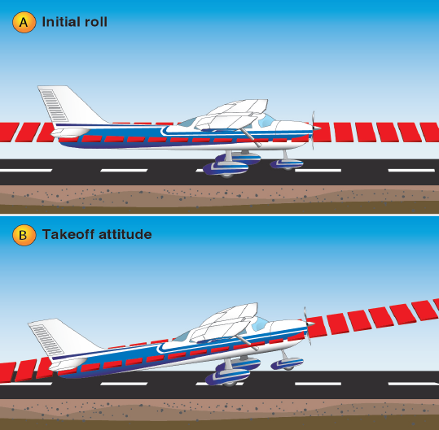
Figure 6-3. Initial roll and takeoff attitude
When all the flight controls become effective during the takeoff roll in a nose-wheel type airplane, the pilot should gradually apply back-elevator pressure to raise the nose-wheel slightly off the runway, thus establishing the takeoff or lift-off attitude. This is the “rotation” for lift-off and climb. As the airplane lifts off the surface, the pitch attitude to hold the climb airspeed should be held with elevator control and trimmed to maintain that pitch attitude without excessive control pressures. The wings should be leveled after lift-off and the rudder used to ensure coordinated flight.
After rotation, the slightly nose-high pitch attitude should be held until the airplane lifts off. Rudder control should be used to maintain the track of the airplane along the runway centerline until any required crab angle in level flight is established. Forcing it into the air by applying excessive back-elevator pressure would only result in an excessively high-pitch attitude and may delay the takeoff. As discussed earlier, excessive and rapid changes in pitch attitude result in proportionate changes in the effects of torque, thus making the airplane more difficult to control.
Although the airplane can be forced into the air, this is considered an unsafe practice and should be avoided under normal circumstances. If the airplane is forced to leave the ground by using too much back-elevator pressure before adequate flying speed is attained, the wing’s AOA may become excessive, causing the airplane to settle back to the runway or even to stall. On the other hand, if sufficient back-elevator pressure is not held to maintain the correct takeoff attitude after becoming airborne, or the nose is allowed to lower excessively, the airplane may also settle back to the runway. This would occur because the AOA is decreased and lift diminished to the degree where it will not support the airplane. It is important, then, to hold the correct attitude constant after rotation or lift-off.
As the airplane leaves the ground, the pilot should keep the wings in a level attitude and hold the proper pitch attitude. Outside visual scans should be intensified at this critical point to attain/maintain proper airplane pitch and bank attitude. Due to the minimum airspeed, the flight controls are not as responsive, requiring more control movement to achieve an expected response. A novice pilot often has a tendency to fixate on the airplane’s pitch attitude and/or the airspeed indicator and neglect bank control of the airplane. Torque from the engine tends to impart a rolling force that is most evident as the landing gear is leaving the surface.
During takeoffs in a strong, gusty wind, it is advisable that an extra margin of speed be obtained before the airplane is allowed to leave the ground. A takeoff at the normal takeoff speed may result in a lack of positive control, or a stall, when the airplane encounters a sudden lull in strong, gusty wind, or other turbulent air currents. In this case, the pilot should allow the airplane to stay on the ground longer to attain more speed, then make a smooth, positive rotation to leave the ground.
Initial Climb
Upon liftoff, the airplane should be flying at approximately the pitch attitude that allows it to accelerate to VY. This is the speed at which the airplane gains the most altitude in the shortest period of time.
If the airplane has been properly trimmed for takeoff, some back-elevator pressure may be required to hold this attitude until the proper climb speed is established. Relaxation of any back-elevator pressure before this time may result in the airplane settling, even to the extent that it contacts the runway.
The airplane’s speed will increase rapidly after it becomes airborne. Once a positive rate of climb is established, the pilot should retract the flaps and landing gear (if equipped). It is recommended that takeoff power be maintained until reaching an altitude of at least 500 feet above the surrounding terrain or obstacles. The combination of VY and takeoff power assures the maximum altitude gained in a minimum amount of time. This gives the pilot more altitude from which the airplane can be safely maneuvered in case of an engine failure or other emergency. The pilot should also consider flying at a lower pitch for cruise climb since flying at VY requires much quicker pilot response in the event of a powerplant failure to preclude a stall.
Since the power on the initial climb is set at the takeoff power setting, the airspeed should be controlled by making slight pitch adjustments using the elevators. However, the pilot should not fixate on the airspeed indicator when making these pitch changes, but should continue to scan outside to adjust the airplane’s attitude in relation to the horizon. In accordance with the principles of attitude flying, the pilot should first make the necessary pitch change with reference to the natural horizon, hold the new attitude momentarily, and then glance at the airspeed indicator to verify if the new attitude is correct. Due to inertia, the airplane will not accelerate or decelerate immediately as the pitch is changed. It takes a little time for the airspeed to change. If the pitch attitude has been over or under corrected, the airspeed indicator will show a speed that is higher or lower than that desired. When this occurs, the cross-checking and appropriate pitch-changing process needs to be repeated until the desired climbing attitude is established. Pilots should remember the climb pitch will be lower when the airplane is heavily loaded, or power is limited by density altitude.
When the correct pitch attitude has been attained, the pilot should hold it constant while cross-checking it against the horizon and other outside visual references. The airspeed indicator should be used only as a check to determine if the attitude is correct.
After the recommended climb airspeed has been established and a safe maneuvering altitude has been reached, the pilot should adjust the power to the recommended climb setting and trim the airplane to relieve the control pressures. This makes it easier to hold a constant attitude and airspeed.
During initial climb, it is important that the takeoff path remain aligned with the runway to avoid drifting into obstructions or into the path of another aircraft that may be taking off from a parallel runway. A flight instructor should help the student identify two points inline ahead of the runway to use as a tracking reference. As long as those two points are inline, the airplane is remaining on the desired track. Proper scanning techniques are essential to a safe takeoff and climb, not only for maintaining attitude and direction, but also for avoiding collisions near the airport.
When the student pilot nears the solo stage of flight training, it should be explained that the airplane’s takeoff performance will be much different when the instructor is not in the airplane. Due to decreased load, the airplane will become airborne earlier and climb more rapidly. The pitch attitude that the student has learned to associate with initial climb may also differ due to decreased weight, and the flight controls may seem more sensitive. If the situation is unexpected, it may result in increased anxiety that may remain until after the landing. Frequently, the existence of this anxiety and the uncertainty that develops due to the perception of an “abnormal” takeoff results in poor performance on the subsequent landing.
Common Errors
Common errors in the performance of normal takeoffs and departure climbs are:
⦁ Failure to review AFM/POH and performance charts prior to takeoff.
⦁ Failure to adequately clear the area prior to taxiing into position on the active runway.
⦁ Abrupt use of the throttle.
⦁ Failure to check engine instruments for signs of malfunction after applying takeoff power.
⦁ Failure to anticipate the airplane’s left turning tendency on initial acceleration.
⦁ Overcorrecting for left turning tendency.
⦁ Relying solely on the airspeed indicator rather than developing an understanding of visual references and tracking clues of airplane airspeed and controllability during acceleration and lift-off.
⦁ Failure to attain proper lift-off attitude.
⦁ Inadequate compensation for torque/P-factor during initial climb resulting in a sideslip.
⦁ Over-control of elevators during initial climb-out and lack of elevator trimming.
⦁ Limiting scan to areas directly ahead of the airplane (pitch attitude and direction), causing a wing (usually the left) to drop immediately after lift-off.
⦁ Failure to attain/maintain best rate-of-climb airspeed (VY) or desired climb airspeed.
⦁ Failure to employ the principles of attitude flying during climb-out, resulting in “chasing” the airspeed indicator.
Crosswind Takeoff
While it is usually preferable to take off directly into the wind whenever possible or practical, there are many instances when circumstances or judgment indicate otherwise. Therefore, the pilot must be familiar with the principles and techniques involved in crosswind takeoffs, as well as those for normal takeoffs. A crosswind affects the airplane during takeoff much as it does during taxiing. With this in mind, the pilot should be aware that the technique used for crosswind correction during takeoffs closely parallels the crosswind correction techniques used for taxiing.
Takeoff Roll
The technique used during the initial takeoff roll in a crosswind is generally the same as the technique used in a normal takeoff roll, except that the pilot needs to apply aileron pressure into the crosswind. This raises the aileron on the upwind wing, imposes a downward force on that wing to counteract the lifting force of the crosswind, and thus prevents the wing from rising. The pilot should remember that since the ailerons and rudder are deflected, drag will increase; therefore, less initial takeoff performance should be expected until the airplane is wings-level in coordinated flight in the climb.
While taxiing into takeoff position, it is essential that the pilot check the windsock and other wind direction indicators for the presence of a crosswind. If a crosswind is present, the pilot should apply full aileron pressure into the wind while beginning the takeoff roll. The pilot should maintain this control position, as the airplane accelerates, and until the ailerons become effective in maneuvering the airplane about its longitudinal axis. As the ailerons become effective, the pilot will feel an increase in pressure on the aileron control.
While holding aileron pressure into the wind, the pilot should use the rudder to maintain a straight takeoff path. [Figure 6-4] Since the airplane tends to weathervane into the wind while on the ground, the pilot will typically apply downwind rudder pressure. When the pilot increases power for takeoff, the resulting P-factor causes the airplane to yaw to the left. While this yaw may be sufficient to counteract the airplane’s tendency to weathervane into the wind in a crosswind from the right, it may aggravate this tendency in a crosswind from the left. In any case, the pilot should apply rudder pressure in the appropriate direction to keep the airplane rolling straight down the runway.
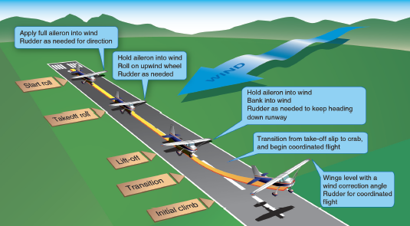
Hold aileron into wind
Bank into wind
Rudder as needed for runway alignment
Transition from takeoff slip to crab
Begin coordinated flight
Figure 6-4. Crosswind roll and takeoff climb
As the forward speed of the airplane increases, the pilot should apply sufficient aileron pressure into the crosswind to keep the wings level. The effect of the crosswind component will not completely vanish; therefore, the pilot needs to maintain some aileron pressure throughout the takeoff roll. If the upwind wing rises, the amount of wing surface exposed to the crosswind will increase, which may cause the airplane to lose lateral alignment with the runway centerline and to "skip." [Figure 6-5] The pilot uses rudder pressure to keep the airplane’s longitudinal axis parallel to the runway centerline.
This “skipping” is usually indicated by a series of very small bounces caused by the airplane attempting to fly and then settling back onto the runway. During these bounces, the crosswind also tends to move the airplane sideways, and these bounces develop into side-skipping. This side-skipping imposes severe side stresses on the landing gear and may result in structural failure.
During a crosswind takeoff roll, it is important that the pilot hold sufficient aileron pressure into the wind not only to keep the upwind wing from rising but to hold that wing down so that the airplane sideslips into the wind enough to counteract drift immediately after lift-off.
Lift-Off
As the nose-wheel lifts off the runway, the pilot should hold aileron pressure into the wind. This may cause the downwind wing to rise and the downwind main wheel to lift off the runway first, with the remainder of the takeoff roll being made on that one main wheel. This is acceptable and is preferable to side-skipping.
If a significant crosswind exists, the pilot should hold the main wheels on the ground slightly longer than in a normal takeoff so that a smooth but very definite lift-off can be made. This allows the airplane to leave the ground under more positive control and helps it remain airborne while the pilot establishes the proper amount of wind correction. More importantly, this procedure avoids imposing excessive side-loads on the landing gear and prevents possible damage that would result from the airplane settling back to the runway while drifting.
As both main wheels leave the runway, the airplane begins to drift sideways with the wind, as ground friction is no longer a factor in preventing lateral movement. To minimize this lateral movement and to keep the upwind wing from rising, the pilot should establish and maintain the proper amount of crosswind correction prior to lift-off by applying aileron pressure into the wind. The pilot should also apply rudder pressure, as needed, to prevent weathervaning.
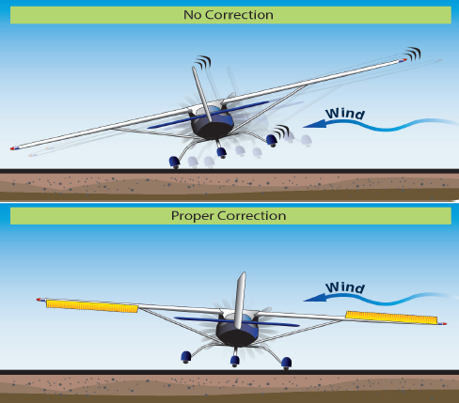
Figure 6-5. Crosswind effect
Initial Climb
If a proper crosswind correction is applied, the aircraft will maintain alignment with the runway while accelerating to takeoff speed and then maintain that alignment once airborne. As takeoff acceleration occurs, the efficiency of the up-aileron will increase with aircraft speed causing the upwind wing to produce greater downward force and, as a result, counteract the effect of the crosswind. The yoke, having been initially turned into the wind, can be relaxed to the extent necessary to keep the aircraft aligned with the runway. As the aircraft becomes flyable and airborne, the wing that is upwind will have a tendency to be lower relative the other wing, requiring simultaneous rudder input to maintain runway alignment. This will initially cause the aircraft to sideslip. However, as the aircraft establishes its climb, the nose should be turned into the wind to offset the crosswind, wings brought to level, and rudder input adjusted to maintain runway alignment (crabbing). [Figure 6-6] Firm and positive use of the rudder may be required to keep the airplane pointed down the runway or parallel to the centerline. Unlike landing, the runway alignment (staying over the runway and its extended centerline) is paramount to keeping the aircraft parallel to the centerline. The pilot should then apply rudder pressure firmly and aggressively to keep the airplane headed straight down the runway. However, because the force of a crosswind may vary markedly within a few hundred feet of the ground, the pilot should check the ground track frequently and adjust the wind correction angle, as necessary. The remainder of the climb technique is the same used for normal takeoffs and climbs.
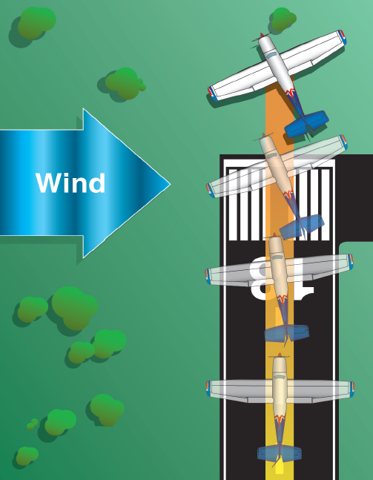
Figure 6-6. Crosswind climb flightpath
The most common errors made while performing crosswind takeoffs include the following:
⦁ Failure to review AFM/POH performance and charts prior to takeoff.
⦁ Failure to adequately clear the area prior to taxiing onto the active runway.
⦁ Using less than full aileron pressure into the wind initially on the takeoff roll.
⦁ Mechanical use of aileron control rather than judging lateral position of airplane on runway from visual clues and applying sufficient aileron to keep airplane centered laterally on runway.
⦁ Side-skipping due to improper aileron application.
⦁ Inadequate rudder control to maintain airplane parallel to centerline and pointed straight ahead in alignment with visual references.
⦁ Excessive aileron input in the latter stage of the takeoff roll resulting in a steep bank into the wind at lift-off.
⦁ Inadequate drift correction after lift-off.
Ground Effect on Takeoff
Ground effect is a condition of improved performance encountered when the airplane is operating very close to the ground. Ground effect can be detected and normally occurs up to an altitude equal to one wingspan above the surface. [Figure 6-7] Ground effect is most significant when the airplane maintains a constant attitude at low airspeed at low altitude (for example, during takeoff when the airplane lifts off and accelerates to climb speed, and during the landing flare before touchdown).
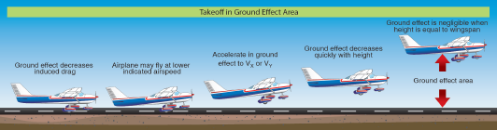
Figure 6-7. Takeoff in ground effect
When the wing is under the influence of ground effect, there is a reduction in upwash, downwash, and wingtip vortices. As a result of the reduced wingtip vortices, induced drag is reduced. When the wing is at a height equal to 1/4 the span, the reduction in induced drag is about 25 percent. When the wing is at a height equal to 1/10 the span, the reduction in induced drag is about 50 percent. At high speeds where parasite drag dominates, induced drag is a small part of the total drag. Consequently, ground effect is a greater concern during takeoff and landing.
At takeoff, the takeoff roll, lift-off, and the beginning of the initial climb are accomplished within the ground effect area. The ground effect causes local increases in static pressure, which cause the airspeed indicator and altimeter to indicate slightly lower values than they should and usually cause the vertical speed indicator to indicate a descent. As the airplane lifts off and climbs out of the ground effect area, the following occurs:
⦁ The airplane requires an increase in AOA. to maintain lift coefficient.
⦁ The airplane experiences an increase in induced drag and thrust required.
⦁ The airplane experiences a pitch-up tendency and requires less elevator travel because of an increase in downwash at the horizontal tail.
⦁ The airplane experiences a reduction in static source pressure and a corresponding increase in indicated airspeed.
V_{X} is the speed at which the airplane achieves the greatest gain in altitude for a given distance over the ground. It is usually slightly less than V_{Y}, which is the greatest gain in altitude per unit of time. The specific speeds to be used for a given airplane are stated in the FAA-approved AFM/POH. The pilot should be aware that, in some airplanes, a deviation of 5 knots from the recommended speed may result in a significant reduction in climb performance; therefore, the pilot should maintain precise control of the airspeed to ensure the maneuver is executed safely and successfully.
Due to the reduced drag in ground effect, the airplane may seem to be able to take off below the recommended airspeed. However, as the airplane climbs out of ground effect below the recommended climb speed, initial climb performance will be much less than at VY or even VX. Under conditions of high density altitude, high temperature, and/or maximum gross weight, the airplane may be able to lift off but will be unable to climb out of ground effect. Consequently, the airplane may not be able to clear obstructions. Lift-off before attaining recommended flight airspeed incurs more drag, which requires more power to overcome. Since the initial takeoff and climb is based on maximum power, reducing drag is the only option. To reduce drag, pitch should be reduced which means losing altitude. Pilots should remember that many airplanes cannot safely takeoff at maximum gross weight at certain altitudes and temperatures, due to lack of performance. Therefore, under marginal conditions, it is important that the airplane takes off at the speed recommended for adequate initial climb performance.
Ground effect is important to normal flight operations. If the runway is long enough or if no obstacles exist, ground effect can be used to the pilot’s advantage by using the reduced drag to improve initial acceleration.
When taking off from an unsatisfactory surface, the pilot should apply as much weight to the wings as possible during the ground run and lift-off, using ground effect as an aid, prior to attaining true flying speed. The pilot should reduce AOA to attain normal airspeed before attempting to fly out of the ground effect areas.
Short-Field Takeoff and Maximum Performance Climb
When performing takeoffs and climbs from fields where the takeoff area is short or the available takeoff area is restricted by obstructions, the pilot should operate the airplane at the maximum limit of its takeoff performance capabilities. To depart from such an area safely, the pilot needs to exercise positive and precise control of airplane attitude and airspeed, so that takeoff and climb performance result in the shortest ground roll and the steepest angle of climb. [Figure 6-8] The pilot should consult and follow the performance section of the AFM/POH to obtain the power setting, flap setting, airspeed, and procedures prescribed by the airplane’s manufacturer.
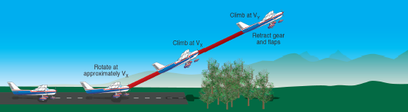
Transition to V_{Y} after obstacle clearance
Initial Climb at V_{X} (obstacle clearance)
Figure 6-8. Short field takeoff
The pilot should have adequate knowledge in the use and effectiveness of the best angle-of-climb speed (VX) and the best rate-of-climb speed (VY) for the specific make and model of airplane being flown in order to safely accomplish a takeoff at maximum performance.
Takeoff Roll
Taking off from a short field requires the takeoff to be started from the very beginning of the takeoff area. At this point, the airplane is aligned with the intended takeoff path. If the airplane manufacturer recommends the use of flaps, they are extended the proper amount before beginning the takeoff roll. This allows the pilot to devote full attention to the proper technique and the airplane’s performance throughout the takeoff.
The pilot should apply takeoff power smoothly and continuously, without hesitation, to accelerate the airplane as rapidly as possible. Some pilots prefer to hold the brakes until the maximum obtainable engine revolutions per minute (rpm) are achieved before allowing the airplane to begin its takeoff run. However, it has not been established that this procedure results in a shorter takeoff run in all light, single-engine airplanes. The airplane is allowed to roll with its full weight on the main wheels and accelerate to the lift-off speed. As the takeoff roll progresses, the pilot should adjust the airplane’s pitch attitude and AOA to attain minimum drag and maximum acceleration. In nose-wheel type airplanes, this involves little use of the elevator control since the airplane is already in a low-drag attitude.
Lift-Off
As V_{X} approaches, the pilot should apply back-elevator pressure until reaching the appropriate V_{X} attitude to ensure a smooth and firm lift-off, or rotation. Since the airplane accelerates more rapidly after lift-off, the pilot should apply additional back-elevator pressure to hold a constant airspeed. After becoming airborne, the pilot will maintain a wings-level climb at V_{X} until all obstacles have been cleared, or if no obstacles are present, until reaching an altitude of at least 50 feet above the takeoff surface. Thereafter, the pilot may lower the pitch attitude slightly and continue the climb at VY until reaching a safe maneuvering altitude. The pilot should always remember that an attempt to pull the airplane off the ground prematurely, or to climb too steeply, may cause the airplane to settle back to the runway or contact obstacles. Even if the airplane remains airborne, until the pilot reaches V_{X}, the initial climb will remain flat, which diminishes the pilot's ability to successfully perform the climb and/or clear obstacles. [Figure 6-9]
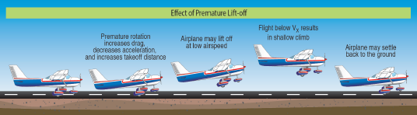
Figure 6-9. Effect of premature liftoff
The objective is to rotate to the appropriate pitch attitude at (or near) VX. The pilot should be aware that some airplanes have a natural tendency to lift off well before reaching VX. In these airplanes, it may be necessary to allow the airplane to lift off in ground effect and then reduce pitch attitude to level until the airplane accelerates to VX with the wheels just clear of the runway surface. This method is preferable to forcing the airplane to remain on the ground with forward elevator-control pressure until VX is attained. Holding the airplane on the ground unnecessarily puts excessive pressure on the nose-wheel and may result in “wheel barrowing.” It also hinders both acceleration and overall airplane performance.
Initial Climb
On short-field takeoffs, the landing gear and flaps should remain in takeoff position until the airplane is clear of obstacles (or as recommended by the manufacturer) and VY has been established. Until all obstacles have been cleared, the pilot should maintain focus outside the airplane instead of reaching for landing gear or flap controls or looking inside the airplane for any reason. When the airplane is stabilized at VY, the landing gear (if retractable) and flaps should be retracted. It is usually advisable to raise the flaps in increments to avoid sudden loss of lift and settling of the airplane. The pilot should next reduce the power to the normal climb setting or as recommended by the airplane manufacturer.
Common errors in the performance of short-field takeoffs and maximum performance climbs are:
⦁ Failure to review AFM/POH and performance charts prior to takeoff.
⦁ Failure to adequately clear the area.
⦁ Failure to utilize all available runway/takeoff area.
⦁ Failure to have the airplane properly trimmed prior to takeoff.
⦁ Premature lift-off resulting in high drag.
⦁ Holding the airplane on the ground unnecessarily with excessive forward-elevator pressure.
⦁ Inadequate rotation resulting in excessive speed after lift-off.
⦁ Inability to attain/maintain VX.
⦁ Fixation on the airspeed indicator during initial climb.
⦁ Premature retraction of landing gear and/or wing flaps.
Soft/Rough-Field Takeoff and Climb
Takeoffs and climbs from soft fields require the use of operational techniques for getting the airplane airborne as quickly as possible to eliminate the drag caused by tall grass, soft sand, mud, and snow and may require climbing over an obstacle. The technique makes judicious use of ground effect to reduce landing gear drag and requires an understanding of the airplane’s slow speed characteristics and responses. These same techniques are also useful on a rough field where the pilot should get the airplane off the ground as soon as possible to avoid damaging the landing gear.
Taking off from a soft surface or through soft surfaces or long, wet grass reduces the airplane’s ability to accelerate during the takeoff roll and may prevent the airplane from reaching adequate takeoff speed if the pilot applies normal takeoff techniques. The pilot should be aware that the correct takeoff procedure for soft fields is quite different from the takeoff procedures used for short fields with firm, smooth surfaces. To minimize the hazards associated with takeoffs from soft or rough fields, the pilot should transfer the support of the airplane’s weight as rapidly as possible from the wheels to the wings as the takeoff roll proceeds by establishing and maintaining a relatively high AOA or nose-high pitch attitude as early as possible. The pilot should lower the wing flaps prior to starting the takeoff (if recommended by the manufacturer) to provide additional lift and to transfer the airplane’s weight from the wheels to the wings as early as possible. The pilot should maintain a continuous motion with sufficient power while lining up for the takeoff roll as stopping on a soft surface, such as mud or snow, might bog the airplane down.
Takeoff Roll
As the airplane is aligned with the takeoff path, the pilot should apply takeoff power smoothly and as rapidly as the powerplant can accept without faltering. As the airplane accelerates, the pilot should apply enough back-elevator pressure to establish a positive AOA and to reduce the weight supported by the nose-wheel.
When the airplane is held at a nose-high attitude throughout the takeoff run, the wings increasingly relieve the wheels of the airplane’s weight as speed increases and lift develops, thereby minimizing the drag caused by surface irregularities or adhesion. If this attitude is accurately maintained, the airplane virtually flies itself off the ground, becoming airborne but at an airspeed slower than a safe climb speed because of ground effect. [Figure 6-10]
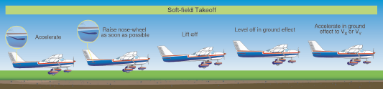
Accelerate in ground effect to recommended climb speed (Vx, Vy or AFM/POH)
Figure 6-10. Soft-field takeoff
Lift-Off
After the airplane becomes airborne, the pilot should gently lower the nose with the wheels clear of the surface to allow the airplane to accelerate to a minimum safe climb out speed, Immediately after the airplane becomes airborne and while it accelerates, the pilot should be aware that, while transitioning out of the ground effect area, the airplane will have a tendency to settle back onto the surface, even with full power applied. Therefore, it is essential that the airplane remain in ground effect until at least VX is reached. This requires a good understanding of the control pressures, aircraft responses, visual clues, and acceleration characteristics of that particular airplane.
Initial Climb
After a positive rate of climb is established, and the airplane has accelerated to VY, the pilot should retract the landing gear and flaps, if equipped. If departing from an airstrip with wet snow or slush on the takeoff surface, the gear should not be retracted immediately so that any wet snow or slush can be air-dried. In the event an obstacle needs to be cleared after a soft-field takeoff, the pilot should perform the climb-out at VX until the obstacle has been cleared. The pilot should then adjust the pitch attitude to VY and retract the gear and flaps. The power can then be reduced to the normal climb setting.
Common errors in the performance of soft/rough field takeoff and climbs are:
⦁ Failure to review AFM/POH and performance charts prior to takeoff.
⦁ Failure to adequately clear the area.
⦁ Insufficient back-elevator pressure during initial takeoff roll resulting in inadequate AOA.
⦁ Failure to cross-check engine instruments for indications of proper operation after applying power.
⦁ Poor directional control.
⦁ Climbing too high after lift-off and not leveling off low enough to maintain ground effect attitude. ⦁ Abrupt and/or excessive elevator control while attempting to level off and accelerate after liftoff. ⦁ Allowing the airplane to "mush" or settle resulting in an inadvertent touchdown after lift-off.
⦁ Attempting to climb out of ground effect area before attaining sufficient climb speed.
⦁ Failure to anticipate an increase in pitch attitude as the airplane climbs our of ground effect.
Rejected Takeoff / Engine Failure
Emergency or abnormal situations can occur during a takeoff that require a pilot to reject the takeoff while still on the runway. Circumstances such as a malfunctioning powerplant, inadequate acceleration, runway incursion, or air traffic conflict may be reasons for a rejected takeoff.
Prior to takeoff, the pilot should identify a point along the runway at which the airplane should be airborne. If that point is reached and the airplane is not airborne, immediate action should be taken to discontinue the takeoff. When properly planned and executed, the airplane can be stopped on the remaining runway without using extraordinary measures, such as excessive braking that may result in loss of directional control, airplane damage, and/or personal injury. The POH/AFM ground roll distances for take-off and landing added together provide a good estimate of the total runway needed to accelerate and then stop.
In the event a takeoff is rejected, the power is reduced to idle and maximum braking applied while maintaining directional control. If it is necessary to shut down the engine due to a fire, the mixture control should be brought to the idle cutoff position and the magnetos turned off. In all cases, the manufacturer’s emergency procedure should be followed.
Urgency characterizes all power loss or engine failure occurrences after lift-off. In most instances, the pilot has only a few seconds after an engine failure to decide what course of action to take and to execute it.
In the event of an engine failure on initial climb-out, the pilot’s first responsibility is to maintain aircraft control. At a climb pitch attitude without power, the airplane is at or near a stalling AOA. At the same time, the pilot may still be holding right rudder. The pilot should immediately lower the nose to prevent a stall while moving the rudder to ensure coordinated flight. The pilot should establish a controlled glide toward a plausible landing area, preferably straight ahead. Any determination regarding the feasibility of a return toward the departure runway should be made prior to takeoff, as limited altitude and time following an engine failure may preclude meaningful analysis once airborne. Attempting to turn back to the takeoff runway should not be considered unless the pilot has previously trained for an emergency turn-back, sufficient altitude exists, and the conduct of the emergency turn-back was considered and briefed prior to the start of the takeoff.
Noise Abatement
Aircraft noise problems are a major concern at many airports throughout the country. Many local communities have pressured airports into developing specific operational procedures that help limit aircraft noise while operating over nearby areas. As a result, noise abatement procedures have been developed for many of these airports that include standardized profiles and procedures to achieve these lower noise goals.
Airports that have noise abatement procedures provide information to pilots, operators, air carriers, air traffic facilities, and other special groups that are applicable to their airport. These procedures are available to the aviation community by various means. Most of this information comes from the Chart Supplements, local and regional publications, printed handouts, operator bulletin boards, safety briefings, and local air traffic facilities.
At airports that use noise abatement procedures, reminder signs may be installed at the taxiway hold positions for applicable runways to remind pilots to use and comply with noise abatement procedures on departure. Pilots who are unfamiliar with these procedures should ask the tower or air traffic facility for the recommended procedures. In any case, pilots should be considerate of the surrounding community while operating their airplane to and from such an airport. This includes operating as quietly, and safely as possible.
Chapter Summary
The takeoff and initial climb are relatively short phases required for every flight and are often taken for granted, yet 1 out of 5 accidents occur during this phase and half the mishaps are the result of pilot error. These risks can be significantly reduced when pilots combine sound technique with deliberate pre-takeoff planning and clear contingency briefing. Becoming proficient in and applying the techniques and principles discussed in this chapter help pilots reduce their susceptibility to becoming a mishap statistic.

